Name Class Date

2.1 Translations

Tell whether the transformation appears to be a rigid motion. Explain.
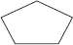  1.  Preimage  Image | 2.  Image  Preimage
3.  Preimage  Image | 4.  Preimage  Image
In each diagram, the dashed-line figure is an image of the solid-line figure.
(a) Choose an angle or point from the preimage and name its image.
(b) List all pairs of corresponding sides.
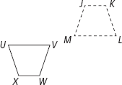
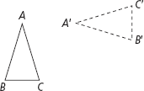
6.
5.

Graph the image of each figure under the given translation.
7. T_{<–1, 4>} (ΔABC) | 8. T_{<3, 3>} (MNOP)
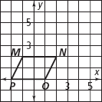
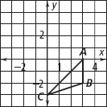

The dashed-line figure is a translation image of the solid-line figure. Write a rule
to describe each translation.
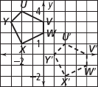
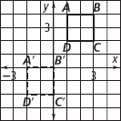
10.
9.

11. You are visiting Washington, D.C. From the American History Museum you
walk 5 blocks east and 1 block south to the Air and Space Museum. Then you
walk 8 blocks west to the Washington Monument. Where is the Washington
Monument in relation to the American History Museum? (Hint: Describe the
movements as a transformation)
12. You and some friends go to a book fair where booths are set out in rows. You
buy drinks at the refreshment stand and then walk 8 rows north and 2 rows
east to the science fiction booth. Then you walk 1 row south and 2 rows west
to the children’s book booth. Where is the children’s book booth in relation to
the refreshment stand?
13. Reasoning If T_{<10, 15>} (PQRS) = P′Q′R′S′, what translation maps P′Q′R′S′
onto PQRS?
14. ΔXYZ has coordinates X(2, 3), Y(1, 4), and Z(8, 9). A translation maps X to
X′(4, 7). What are the coordinates for Y′ and Z′ for this translation?
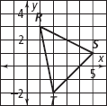
15. Use the graph at the right. Write three different
translation rules for which the image of ΔRST
has a vertex at the origin.

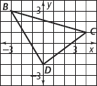
16. Use the graph at the right. Write three different
translation rules for which the image of ΔBCD has
a vertex at the origin.

Graph the image of each figure under the given translation.
18. T_{<–5, 1>} (KLMN)
17. T_{<–3, 4>} (ΔDEF)
