Name

Class

Date

Slopes of Parallel and Perpendicular Lines

**In Exercises 1 and 2, are lines *m*1 and *m*2 parallel? Explain.**

1.

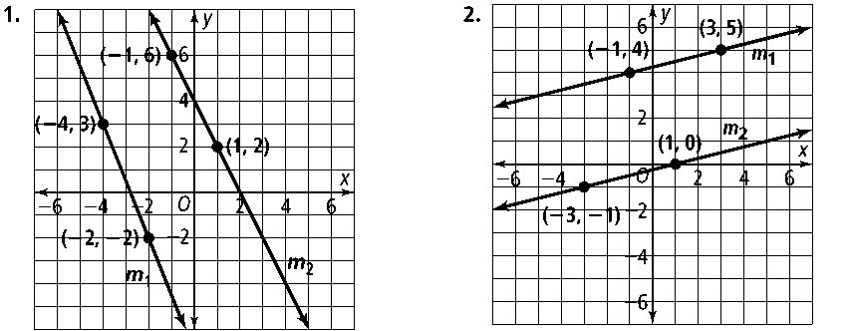**1. 2.**

**Write an equation of the line parallel to that contains point *C.***

**3. ***: y* = −5*x* + 12; *C*(−2, 1) **4. ***: y* = *x* + 7** ; *C*(7, 1)

**5. ***: y* = *x* + 8** ; *C*(3, 6) **6. ***: y* = −*x* + 5**; *C*(5, −2)

**In Exercises 7 and 8, are lines *m*1 and *m*2 perpendicular? Explain.**

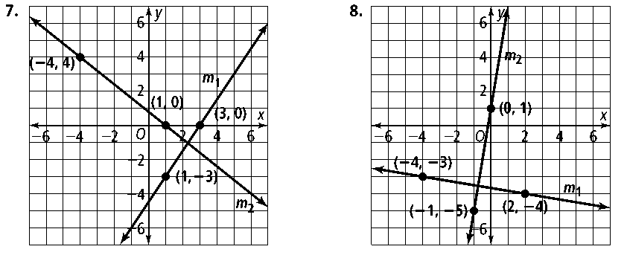**7. 8.**

**Write an equation of the line perpendicular to the given line that contains *P.***

**9.** *P*(−6, 5); *y* = 2*x* − 3 **10.** *P*(4, 3); *y* = −3*x* − 15

**11.** *P*(−6, −3); *y* = *x−* 1 **12.** *P*(5, 5); *y* = ** *x* + 11**

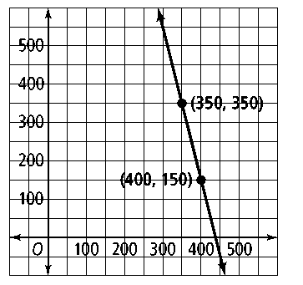**13.** The line that represents the right boundary of a street is shown on the grid at the right.

**a.** What is the equation of the left boundary, which is parallel to the right boundary, and passes through point *L*(200, 100)?

**b.** Graph the left boundary.

**Rewrite each equation in slope intercept form. Then determine whether the lines are parallel. Explain.**

**14.** 2*y* = *x* + 15 **15.** 10*y* + 130 = 50*x* **16.** 2*y* = 15 + 4*x*

*x* = 2*y* + 5 −5*y* = 2*x* + 11 6*y* − 30 = 12*x*

**Rewrite each equation in slope-intercept form. Then determine whether the lines are perpendicular. Explain.**

**17.** *y* − 1 = −*x* −6 **18.** **19.** 

 2*y* = 8*x* + 18 5*y* = 2*x* + 6