Name Class Date

The Pythagorean Theorem Part 2
Algebra Find the value of x.
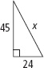
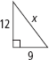
2.
1.

4.
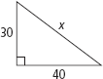
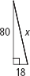
3.

Does each set of numbers form a Pythagorean triple? Explain.
5. 6, 8, 10
6. 7, 16, 18
7. 16, 30, 34
Algebra Find the value of x. Express your answer in simplest radical form.
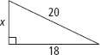
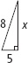
10.
8.
9.
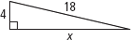

13.
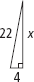
12.
11.
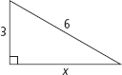
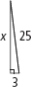

14. A window washer has an 18-ft ladder. He needs to reach the bottom of a
window 16 feet off the ground. How far out from the building should the
base of the ladder be? Round to the nearest tenth of a foot.

Is each triangle a right triangle? Explain.
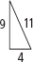
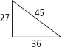
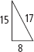
17.
16.
15.

The lengths of the sides of a triangle are given. Classify each triangle as acute,
right, or obtuse.
18. 9, 11, 16 | 19. 4, 6, 7 | 20. 6, 8, 12
21. 24, 70, 74 | 22. 10, 12, 14 | 23. 20, 25, 31

