1. Which student response is the most precise definition of an angle?
A. A line that is bent about a center point.
B. Two different rays that have a common endpoint.
C. Two lines that intersect creating an ‘X’.
D. Two non‐parallel lines in different plans that never intersect.

2. Which of the following is a precise definition of perpendicular lines?
A. Lines q and p are perpendicular if they never meet.
B. Lines q and p are perpendicular if they meet at a single point so that the two lines form a ‘T’.
C. Lines q and p are perpendicular if they meet at a single point and if one of the angles at the
point of intersection is a right angle.
D. Lines q and p are perpendicular if they intersect at the midpoint of q.
3. Which of the following is a precise definition of a circle?
A. The set of all points in a plane that are equidistant from a given center point.
B. A three‐dimensional shape whose boundary consists of all points equidistant from a given
center point.
C. The set of all points in a two‐dimensional plane that create a diameter.
D. The set of all points that are equidistant to the focus and directrix.
4. Which student response is the most precise definition of a line segment?
A. A line segment is part of a line, not the whole thing.
B. A line segment is when three points are all on the same line.
C. A line segment has an endpoint and continues forever in one direction.
D. A line segment is part of a line connecting two endpoints.
5. Which student response is the most precise definition of two parallel lines?
A. Two lines are parallel if they are distinct and one can be translated on top of the other.
B. Two lines are parallel if they are close together but do not intersect.
C. Two lines are parallel as long as they are not perpendicular.
D. Two lines are parallel if they do not intersect and are in different planes.
6.
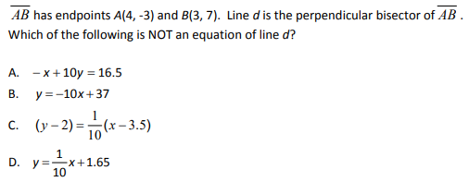

7.
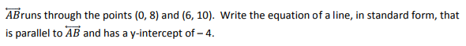

8.

9.
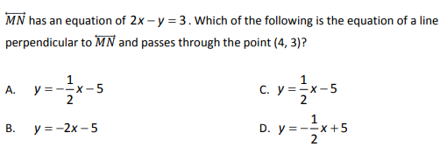

10.
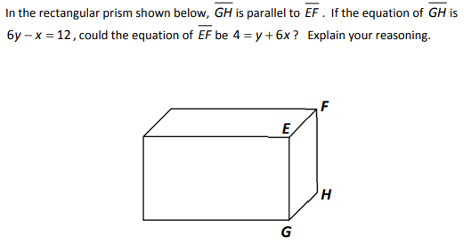

11.
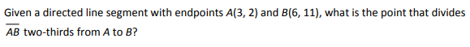

12.

13.

14.

15.

16.

