Dilations
The solid-line figure is a dilation of the dashed-line figure. The labeled point is the center of dilation. Tell whether the dilation is an enlargement or a reduction. Then find the scale factor of the dilation.
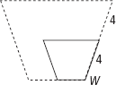
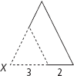
2.
1.

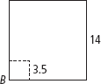
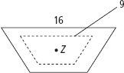
4.
3.

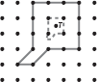
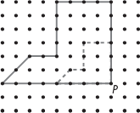
6.
5.

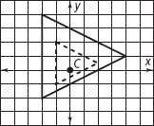
8.
7.
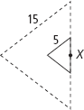

You look at each object described in Exercises 9–11 under a magnifying glass.
Find the actual dimension of each object.
9. The image of a ribbon is 10 times the ribbon’s actual size and has a width of 1 cm.
10. The image of a caterpillar is three times the caterpillar’s actual size and has a width of 4 in.
11. The image of a beetle is five times the beetle’s actual size and has a length of 1.75 cm.
12. ΔP′Q′R′ is a dilation image of ΔPQR. The scale factor for the dilation is 0.12. Is the dilation an enlargement or a reduction?

A dilation has center (0, 0). Find the image of each point for the given scale factor.

13. X(3, 4); D₇(X) | 14. P(–3, 5); D_{1. 2}(P)
15. Q(0, 4); D_{3.4}(Q) | 16. T(–2, –1); D₄(T)
17. S(5, –6); (S) | 18. M(2, 2); D₅(M)
19. A square has 16-cm sides. Describe its image for a dilation with center at one of the vertices and scale factor 0.8.

20. Graph pentagon ABCDE and its image A′B′C′D′E′ for a dilation with center (0, 0) and a scale factor of 1.5. The vertices of ABCDE are: A(0, 3), B(3, 3), C(3, 0), D(0, –3), E(–1, 0).

