5.9 Angles of Elevation and Depression

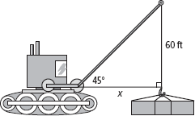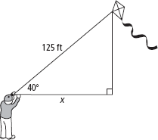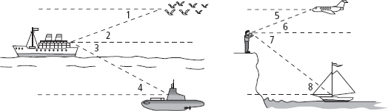**Describe each angle as it relates to the situation in the diagram.**

**9.**

**11.**

|  |  |  |  |
| --- | --- | --- | --- |
| **1.** | **2.** | **3.** | **4.** |
| **5.** | **6.** | **7.** | **8.** |

**Find the value of *x.* Round to the nearest tenth of a unit.**

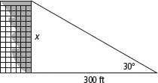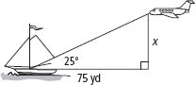

**10.**

**12.**

**13.** A person is standing 40 ft from a flagpole and can see the top of the pole at a  
35° angle of elevation. The person’s eye level is 4 ft from the ground. What is  
the height of the flagpole to the nearest foot?

**14.** An eagle perched 40 ft up in a tree looks down at a 35° angle and spots a vole.  
How far is the vole from the eagle to the nearest tenth of a foot?

**15.** You stand 40 ft from a tree. The angle of elevation from your eyes (5 ft above  
the ground) to the top of the tree is 47°. How tall is the tree? Round your  
answer to the nearest foot.

**Find the value of *x.* Round to the nearest tenth of a unit.**

**16.**

**17.**

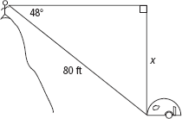

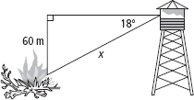

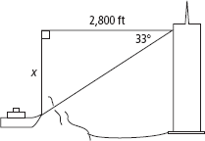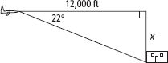

**19.**

**18.**

**20.** An airplane is flying at an altitude of 10,000 ft. The airport at which it is  
scheduled to land is 50 mi away. Find the average angle at which the airplane  
must descend for landing. Round your answer to the nearest degree.

**21.** A lake measures 600 ft across. A lodge stands on one shore. From your point  
on the opposite shore, the angle of elevation to the top of the lodge is 4°.  
How high above the lake does the lodge stand? Round your answer to the  
nearest foot.

**22.** A library needs to build an access ramp for wheelchairs. The main entrance to  
the library is 8 ft above sidewalk level. If the architect designs the slope of the  
ramp in such a way that the angle of elevation is 5°, how long must the access  
ramp be? Round your answer to the nearest foot.

**Algebra The angle of elevation *e* from *A* to *B* and the angle of depression *d* from  
*B* to *A* are given. Find the measure of each angle.**

|  |  |
| --- | --- |
| **23.** *e*: (3*x* + 6)°, *d*: (*x* + 20) | **24.** *e*: (6*x* + 3)°, *d*: 3(*x* + 6) |
| **25.** *e*: (3*x* − 4)°, *d*: 2(*x* + 7) | **26.** *e*: (5*x* − 8)°, *d*: 3(*x* + 4) |