Name Class Date

5.8 Trigonometry
Write the ratios for sin X, cos X, and tan X.
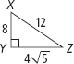
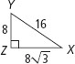
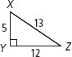
3.
2.
1.

Find the value of x. Round to the nearest tenth.
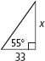
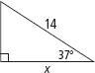
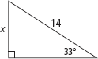
5.
7.
4.

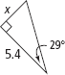
6.

8. An escalator at a shopping center is 200 ft 9 in. long, and rises at an
angle of 15°. What is the vertical rise of the escalator? Round to the
nearest inch.
9. A 12-ft-long ladder is leaning against a wall and makes a 77° angle
with the ground. How high does the ladder reach on the wall?
Round to the nearest inch.
10. A straight ramp rises at an angle of 25.5° and has a base 30 ft long. How high is
the ramp? Round to the nearest foot.
Find the value of x.Round to the nearest degree.

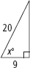
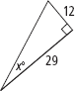
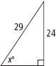
14.
12.
11.

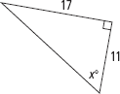
13.

15. The lengths of the diagonals of a rhombus are 4 in. and 7 in. Find the measures
of the angles of the rhombus to the nearest degree.
16. The lengths of the diagonals of a rhombus are 5 in. and 8 in. Find the measures
of the angles of the rhombus to the nearest degree.
Find the values of w and then x. Round lengths to the nearest tenth and angle
measures to the nearest degree.
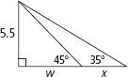
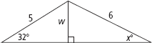
18.
17.

19. Reasoning Does sin A + sin B = sin (A + B) when 0 < A + B < 90?
Explain your reasoning.
20. A right triangle has a hypotenuse of length 10 and one leg of length 7. Find the
length of the other leg and the measures of the acute angles in the triangle.
Round your answers to the nearest tenth
21. A right triangle has an angle that measures 28. The leg opposite the 28° angle
measures 13. Find the length of the other leg and the hypotenuse. Round your
answers to the nearest tenth.

