Name Class Date

5.7 Special Right Triangles

**Find the value of each variable. If your answer is not an integer, express it in  
simplest radical form.**

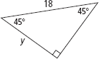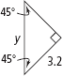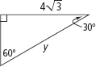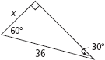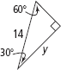

**3.**

**1.**

**2.**

**4.**

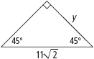

**6.**

**5.**

**The side lengths of a triangle are given. Determine if the triangle is a 45°-45°-90°  
triangle, a 30°-60°-90° triangle, or neither.**

|  |  |
| --- | --- |
| **7.** 40, 50, 80 | **8.** |
| **9.** | **10.** |

**11.** A square has side length 95. What is the length of the diagonal of the square?  
Express your answer in simplest radical form.

**12.** A square has diagonal length 13 m. What is the side length of the square, to the  
nearest centimeter?

**13.** A professional baseball diamond is a square. The distance from base to base is  
90 ft. To the nearest foot, how far does a catcher standing at home plate throw  
the ball across the diagonal of the square to second base?

**14.** Children climb 8 ft to get to the top of a slide. The end of the slide is 1 ft above  
the ground and the slide rises at a 45° angle. If the slide makes a straight line  
from the top to the bottom, how far does a child travel down the slide? Round  
to the nearest foot.

**15.** You set up a makeshift greenhouse by leaning a square pane of glass against  
a building. The glass is 4.5 ft long, and it makes a 30° angle with the ground.  
How much horizontal distance between the building and the glass is there to  
grow plants? Round to the nearest inch.

**16.** A square tablecloth has a line of embroidered flowers along the diagonal. The  
tablecloth is 48 in. on each side. How long is the embroidery line? Round to  
the nearest inch.

**17.** An equilateral triangle has height 26 cm. What is the length of each side of the  
triangle, to the nearest centimeter?

**Find the value of each variable. If your answer is not an integer, express it in  
simplest radical form.**

**18.**

**19.**

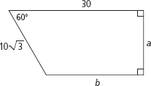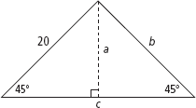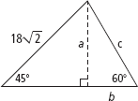

**20.**

**21.**

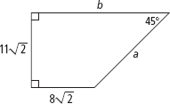

**22.** Right triangle *ABC* has area 32.The measure of  = 30,  
*=* 90. What is the length of *BC*? *AB*? *AC*?Express all answers in  
simplest radical form.

**23.** An equilateral triangle has perimeter 120 in. What is the area of the triangle?  
Express your answer in simplest radical form.