Name

Class

Date

5.6 Congruence in Right Triangles

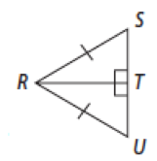**1. Developing Proof** Complete the paragraph proof.

**Given: **

**Prove:** *∆RUT* ≅ *∆RST*

**Proof:** It is given that . So, _____ and _______are _______ angles

because perpendicular lines form ______ angles. _______ ≅ by the

Reflexive Property of Congruence. It is given that _______ ≅*.* So,  
*∆RUT* ≅ *∆RST* by _______.

**2.** Look at Exercise 1. If *m*∠RST = 46, what is *m*∠RUT?

**Algebra For what values of *x* or *x* and *y* are the triangles congruent by HL?**

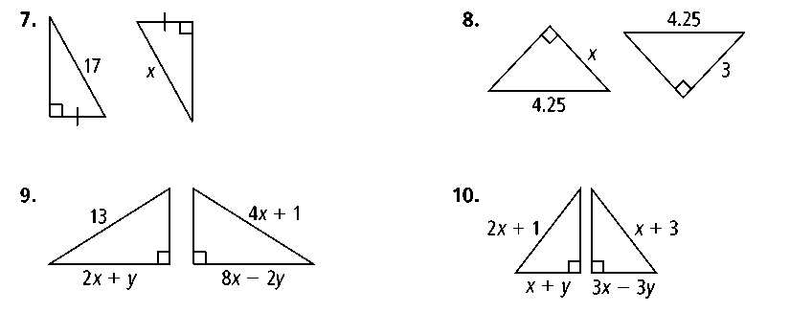**3. 4.**

**5. 6.**

**What additional information would prove each pair of triangles congruent by the  
Hypotenuse-Leg Theorem?**

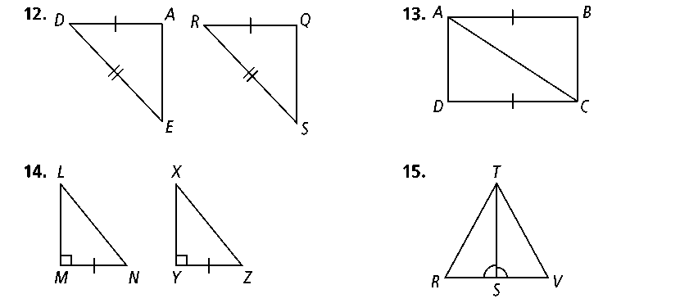**7. 8.**

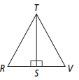**9. 10.**

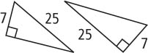**11. Reasoning** Are the triangles congruent? Explain.