Name

Class

Date

5.5 Similarity in Right Triangles

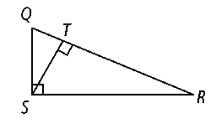

**Identify the following in right Δ*QRS.***

**1.** the hypotenuse **2.** the segments of the hypotenuse

**3.** the altitude **4.** the segment of the hypotenuse adjacent to leg 

**Write a similarity statement relating the three triangles in the diagram.**

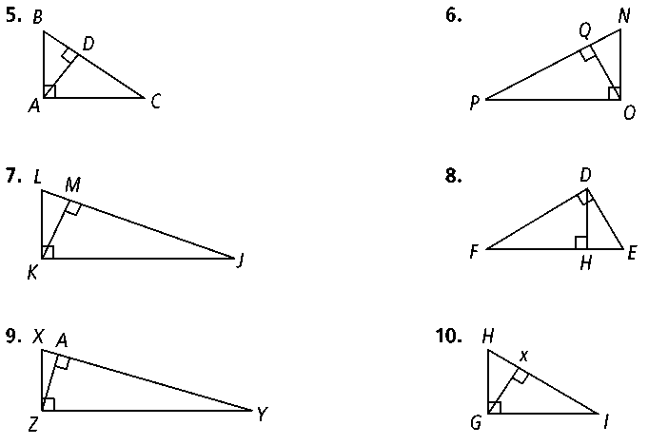**5. 6.**

**7. 8.**

**Algebra Find the geometric mean of each pair of numbers.**

**11.** 9 and 4 **12.** 14 and 6 **13.** 9 and 30

**14.** 25 and 49 **15.** 4 and 120 **16.** 9 and 18

**Use the figure at the right to complete each proportion.**

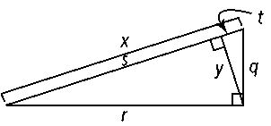**20.  21.**  **22.** 

**23.  24.  25. **

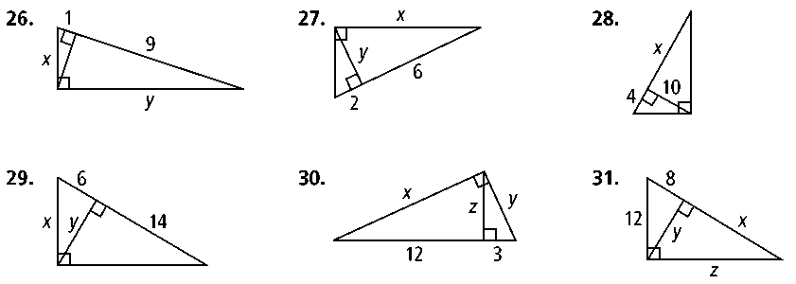**Algebra Solve for the value of the variables in each right triangle.**

**26. 27. 28.**

**29. 30. 31.**

**36.** The altitude of the hypotenuse of a right triangle divides the hypotenuse into 45 in. and 5 in. segments. What is the length of the altitude?