Name Class Date

5.2 The Pythagorean Theorem and Its Converse

Algebra Find the value of y. Express in simplest radical form.
3.
2.
1.
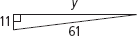
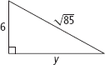
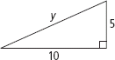

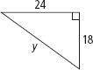
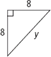
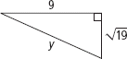
6.
5.
4.

The lengths of the sides of a triangle are given. Classify each triangle as acute,
right, or obtuse.
7. 3, 8, 10 | 8. 4, 5, 7 | 9. 12, 15, 19
10. A square has side length 10 yd. What is the length of a diagonal of the square?
Express in simplest radical form.
11. A square has diagonal length 9 m. What is the side length of the square, to the
nearest centimeter?
12. A repairman leans the top of an 8-ft ladder against the top of a stone wall. The
base of the ladder is 5.5 ft from the wall. About how tall is the wall? Round to
the nearest tenth of a foot.

13. A river runs straight through the center of a park. A man stands on one bank
of the river, and his daughter stands across the river and 22 ft upstream. The
man’s son swims from the man to his daughter. If the river is 11 ft wide, how
far does the son swim? Round to the nearest foot.

For each pair of numbers, find a third whole number such that the three
numbers form a Pythagorean triple.
14. 13, 84 | 15. 16, 12 | 16. 32, 60
17. 80, 18 | 18. 99, 20 | 19. 75, 100

Is each triangle a right triangle? Explain.
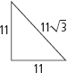
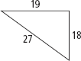
21.
20.

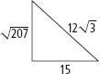
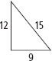
22.
23.

24. A square is drawn inside a circle so that its vertices touch the circle. If the
radius of the circle is 15 cm, what is the perimeter of the square?
25. The playing surface of a football field is 300 ft long and 160 ft wide. If a
player runs from one corner of the field to the opposite corner, how many
feet does he run?
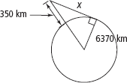
26. The International Space Station orbits 350 km above
Earth’s surface. Earth’s radius is about 6370 km. Use the
Pythagorean Theorem to find the distance from the space
station to Earth’s horizon. Round your answer to the nearest
10 kilometers. (Diagram is not to scale.)

