Name
Class
Date

5.1 Hinge Theorem

Write an inequality relating the given side lengths. If there is not enough information to reach a conclusion, write no conclusion.
1. ST and MN 2. BA and BC 3. CD and CF

4. A crocodile opens his jaws at a 30 angle. He closes his jaws, then opens them again at a 36 angle. In which case is the distance between the tip of his upper jaw and the tip of his lower jaw greater? Explain.
5. At which time is the distance between the tip of the hour hand and the tip of the minute hand greater, 2:20 or 2:25?
Find the range of possible values for each variable.
6. 7. 8.

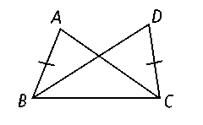
9. In the triangles at the right, AB = DC and m∠ABC < m∠DCB. Explain why AC < BD.

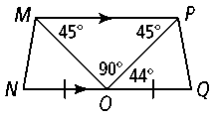
Copy and complete with > or <. Explain your reasoning.
10. m∠POQ m∠MON
11. MN PQ
12. MP OP

13. Jogger A and Jogger B start at the same point. Jogger A travels 0.9 mi due east, then turns 120° clockwise, then travels another 3 mi. Jogger B travels 0.9 mi due west, then turns 115° counterclockwise, then travels another 3 mi. Do the joggers end in the same place? Explain.

14. The legs of an isosceles triangle with a 65° vertex angle
are congruent with the sides of an equilateral triangle.
Which triangle has a greater perimeter? How do you know?

Write an inequality relating the given angle measures. If there is not enough information to reach a conclusion, write no conclusion.
15. m∠A and m∠F 16. m∠L and m∠R 17. m∠MLN and m∠ONL

