Name

Class

Date

4.9 Perpendicular and Angle Bisectors

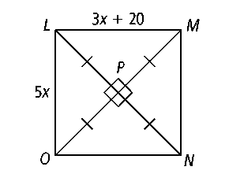

**Use the figure at the right for Exercises 1–4.**

**1.** What is the relationship between  and *?*

**2.** What is the value of *x?*

**3.** Find *LM.* **4.** Find *LO.*

**Use the figure at the right for Exercises 5–8.**

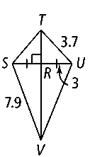

**5.** From the information given in the figure, how is  related to *?*

**6.** Find *TS.* **7.** Find *UV.* **8.** Find *SU.*

**9.** At the right is a layout for the lobby of a building placed on a coordinate grid.

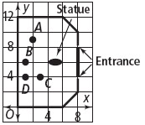

**a.** At which of the labeled points would a receptionist chair be equidistant from both entrances?

**b.** Is the statue equidistant from the entrances? How do you know?

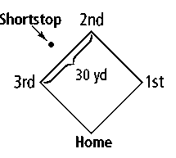

**10.** In baseball, the baseline is a segment connecting the bases. A shortstop is told to play back 3 yd from the baseline and exactly the same distance from second base and third base. Describe how the shortstop could estimate the correct spot. There are 30 yd between bases. Assume that the shortstop has a stride of 36 in.

**Use the figure at the right for Exercises 11–15.**

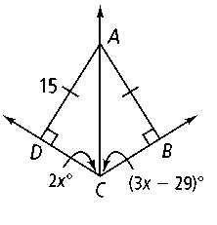**11.** According to the figure, how far is *A* from *?* from *?*

**12.** How is  related to ∠*DCB?* Explain.

**13.** Find the value of *x.*

**14.** Find *m*∠*ACD* and *m*∠*ACB.*

**15.** Find *m*∠*DAC* and *m*∠*BAC.*

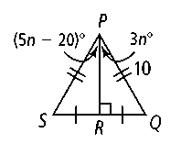

**Use the figure at the right for Exercises 16–19.**

**16.** According to the diagram, what are the lengths of  and *?*

**17.** How is related to ∠*SPQ?*

**18.** Find the value of *n.*

**19.** Find *m*∠*SPR* and *m*∠*QPR.*

**Algebra Find the indicated variables and measures.**

**20.** *x, BA, DA* **21.** *x, m*∠*DEF* **22.** *x, m*∠*DAB*

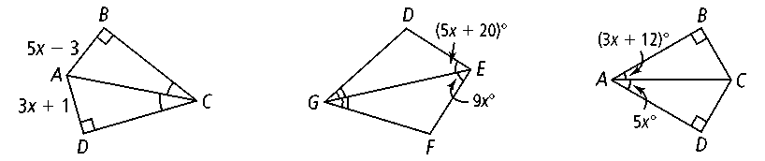

**23.** *m, LO, NO* **24.** *x, m*∠*QTS* **25.** *p, IJ, KJ*

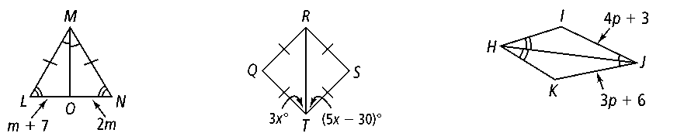

**26.** *r, UW* **27.** *y, m*∠*DEF* **28.** *m, p*

