Name

Class

Date

4.8 Midsegments of Triangles

**Identify three pairs of triangle sides in each diagram.**

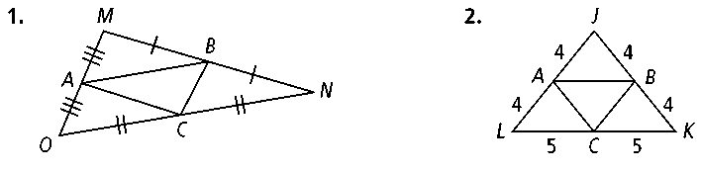**1. 2.**

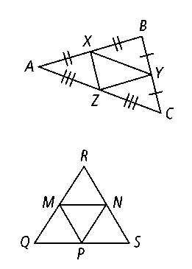**Name the triangle sides that are parallel to the given side.**

**3. ****4. **

**5. ****6. **

**7. ****8. **

**Points *M, N,* and *P* are the midpoints of the sides of *QRS. QR*** = **30, *RS*** = **30, and *SQ*** = **18.**

**9.** Find *MN.* **10.** Find *MQ.*

**11.** Find *MP.* **12.** Find *PS.*

**13.** Find *PN.* **14.** Find *RN.*

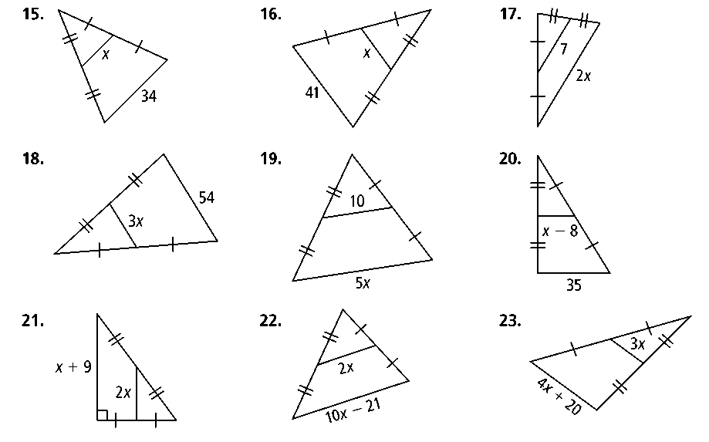**Algebra Find the value of *x.***

**15. 16.**



**17. 18.**

**19. 20.**

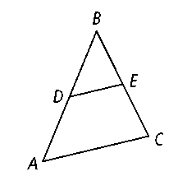

***D* is the midpoint of *. E* is the midpoint of *.***

**21.** If *m*∠*A* = 70, find *m*∠*BDE.*

**22.** If *m*∠*BED* = 73, find *m*∠*C.*

**23.** If *DE* = 23, find *AC.*

**24.** If *AC* = 83, find *DE.*

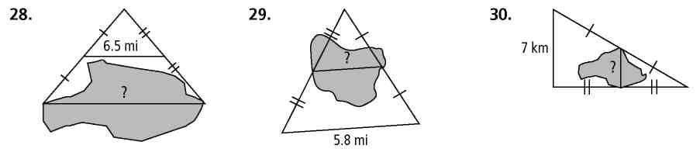**Find the distance across the lake in each diagram.**

**25. 26. 27.**

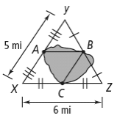

**Use the diagram at the right for Exercises 31 and 32.**

**28.** Which segment is shorter for kayaking across the lake,  or *?* Explain.

**29.** Which distance is shorter, kayaking from *A* to *B* to *C,* or walking from *A* to *X* to *C?* Explain.

**30.** **Coordinate Geometry** The coordinates of the vertices of a triangle are *K*(2, 3), *L*(−2, −1), and *M*(5, 1).

**a.** Find the coordinates of *N,* the midpoint of *,* and *P,* the midpoint of*.*

**b.** Show that .

**c.** Show that 