Name
Class
Date

4.7 Areas of Parallelograms and Triangles

Find the area of each parallelogram.
Find the value of h for each parallelogram.
Find the area of each triangle.
1. 2. 3.

4. 5. 6.

7. 8. 9.

10. 11. 12.

13. 14. 15.

16. Algebra In a parallelogram, a base, b, and its corresponding height, h, are in the ratio of 5 : 3. The area is 135 mm². Find b and h.
17. Reasoning A triangle has an area of 18 ft². List all the possible positive integers that could represent its base and height.

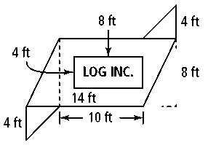
18. A company wants to paint its logo on the side of a building. The entire area needs to be covered with a primer. The two triangular areas will be painted red, the rectangle containing the company’s name will be white, and the rest of the parallelogram will be yellow.
a. Find the area for each different color.
b. Find the area that must be painted with primer.

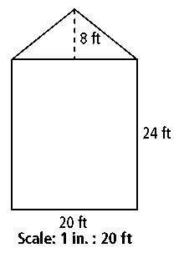
19. A scale drawing of the side view of a house is shown at the right. Find the total area (in square inches) of the side of the house in the drawing.

Coordinate Geometry Find the area and perimeter of a polygon with the given vertices.
20. A(2, 2), B(5, 2), C(3, −1), D(0, −1)
21. A(1, 4), B(−2, −2), C(−7, −2), D(−4, 4)
Find the area of each figure.

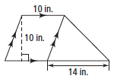
22. 23. 24.

25. A parallelogram has sides 24 m and 5 m. The height corresponding to a 24-m base is 4 m. What it the height corresponding to a 5-m base?

