Name

Class

Date

4.6 Isosceles and Equilateral Triangles

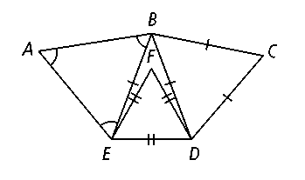

**Complete each statement. Explain why it is true.**

**1.** ∠*DBC* ≅ ≅ ∠*CDB*

**2.** ∠*BED* ≅

**3.** ∠*FED* ≅ ≅ ∠*DFE*

**4*.*** *AB* ≅ ≅

**Algebra Find the values of *x* and *y.***

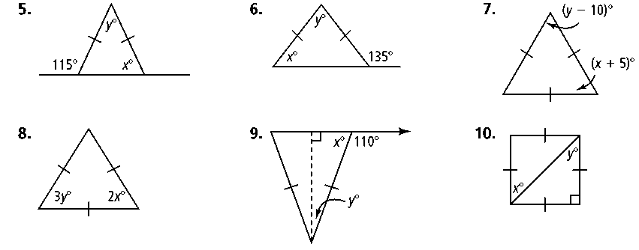**5. 6.**  **7.**

**8. 9.**  **10.**

**Use the properties of isosceles and equilateral triangles to find the measure of the indicated angle.**

**11.** *m*∠*ACB* **12.** *m*∠*DBC* **13.** *m*∠*ABC*

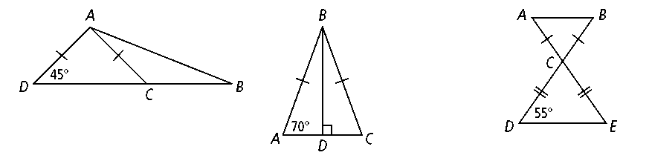

**14.** Equilateral triangle** and isosceles triangle share side *BC*. If *m*∠*BDC* = 34 and *BD* = *BC,* what is the measure of ∠*ABD?* (*Hint:* it may help to draw the figure described.)

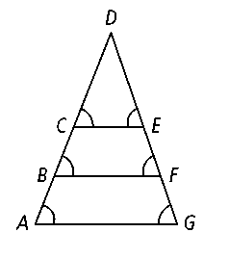

**Use the diagram for Exercises 15–17 to complete each congruence statement. Explain why it is true.**

**15*. ***≅

**16*. ***≅

**17*. ***≅

**18.** The wall at the front entrance to the Rock and Roll Hall of Fame and Museum in Cleveland, Ohio, is an isosceles triangle. The triangle has a vertex angle of 102. What is the measure of the base angles?

**19. Reasoning** An exterior angle of an isosceles triangle has the measure 130. Find two possible sets of measures for the angles of the triangle.

**Algebra Find the values of *m* and *n.***

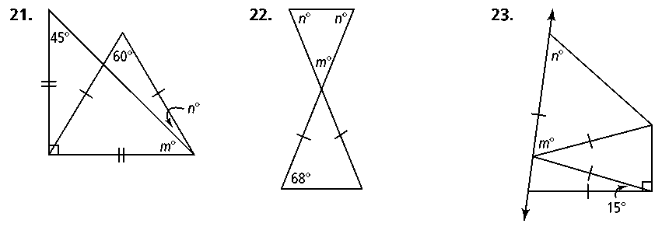**21. 22. 23.**