Class

Class

Date

Name

4.4 Triangle Congruence by ASA and AAS

**Name two triangles that are congruent by ASA.**

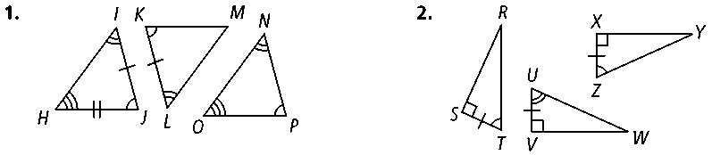**1. 2.**

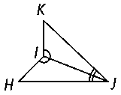**3. Developing Proof** Complete the proof by filling in the blanks. **Given: ∠***HIJ* ≅ ∠*KI*

*∠IJH* ≅ ∠*IJK*

**Prove: Δ***HIJ* ≅ **Δ***KIJ*

**Proof: ∠***HIJ* ≅ ∠*KIJ* and ∠*IJH* ≅ ∠*IJK* are given.

** ≅ ** byhari.

So, **Δ***HIJ* ≅ **Δ***KIJ* byhari.

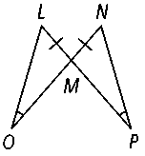**4. Given:** ∠*LOM* ≅ ∠*NPM, * ≅ 

**Prove: Δ***LOM* ≅ **Δ***NPM*

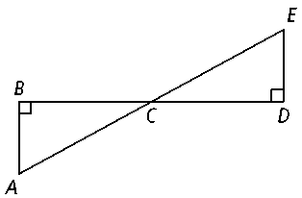**5. Given:** ∠*B* and ∠*D* are right angles.

** bisects 

**Prove: Δ***ABC* ≅ **Δ***EDC*

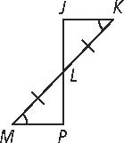**6.** Write a two-column proof. **Given:** ∠*K* ≅ ∠*M*

** ≅ 

**Prove: Δ***JKL* ≅ **Δ***PML*

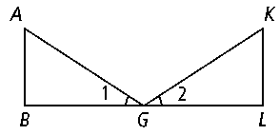**7. Developing Proof** Complete the proof.

**Given:** ∠1 ≅ ∠2,  *, *  *, * ≅ 

**Prove: Δ***ABG* ≅ **Δ***KLG*

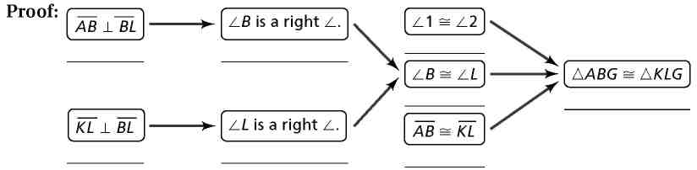**Proof:**

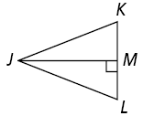**For Exercises 9 and 10, write a paragraph proof.**

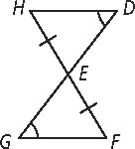**8. Given:** ∠*D* ≅ ∠*G*

** ≅ 

**Prove: Δ***EFG* ≅ **Δ***EHD*

**9. Given: **bisects ∠*J*.

* * 

**Prove: Δ***JMK* ≅ **Δ***JML*