Name

Class

Date

4.3 Triangle Congruence by SSS and SAS

**Draw** Δ***MGT.* Use the triangle to answer the questions below.**

**1.** What angle is included between and *?*

**2.** Which sides include *?*

**3.** What angle is included between  and *?*

**Would you use SSS or SAS to prove the triangles congruent? If there is not enough information to prove the triangles congruent by SSS or SAS, write *not enough information.* Explain your answer.**

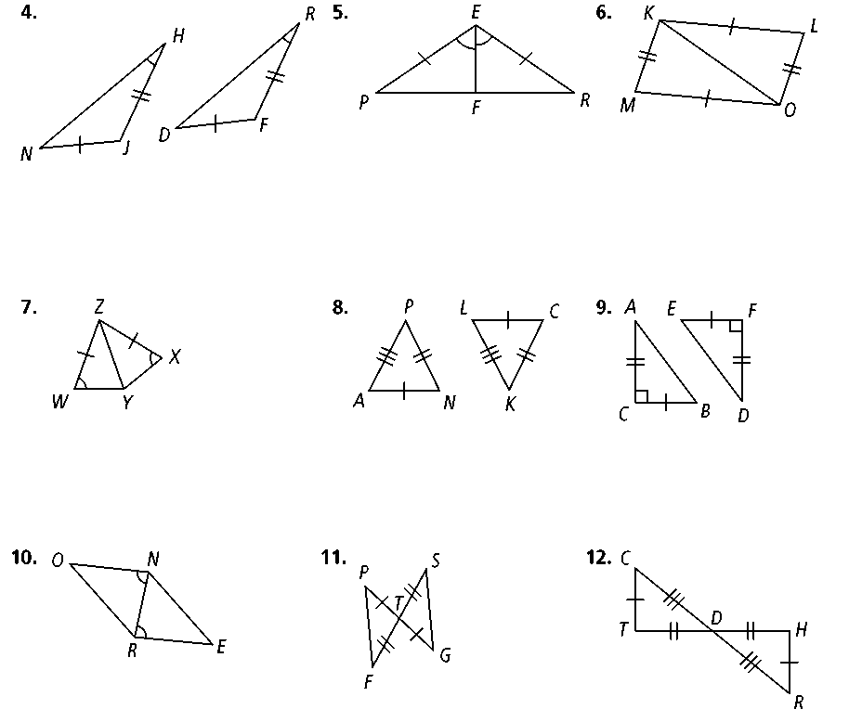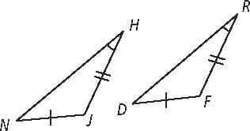**4. 5. 6.**



 **7. 8. 9.**

 **10. 11. 12.**

**13. Draw a Diagram** A student draws Δ*ABC* and Δ*QRS.* The following sides and angles are congruent:

* * ∠*B* ≅ ∠*R*

Based on this, can the student use either SSS or SAS to prove that Δ*ABC ≅* Δ*QRS?* If the answer is no, explain what additional information the student needs. Use a sketch to help explain your answer

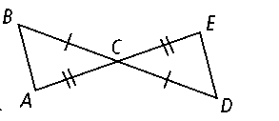**14. Given:** **

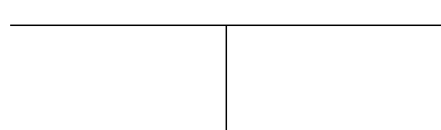

**Reasons**

**Statements**

**Prove:** Δ*ABC* ≅ Δ*EDC*

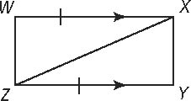**15. Given: **

**Prove:** Δ*WXZ* ≅ Δ*YZX*

**Algebra Find the values of the variables.**

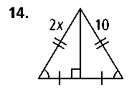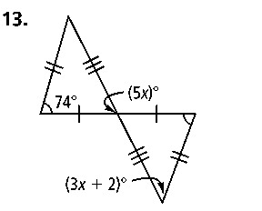**16. 17.**

**Algebra *ABCD* ≅** ***FGHJ.* Find the measures of the given angles or lengths of the given sides.**

**18.** *m*∠*B* = 3*y, m*∠*G* = *y* + 50 **19.** *CD* = 2*x* + 3; *HJ* = 3*x* + 2

**20.** *m*∠*C* = 5*z* + 20, *m*∠*H* = 6*z* + 10 **21.** *AD* = 5*b* + 4; *FJ* = 3*b* + 8

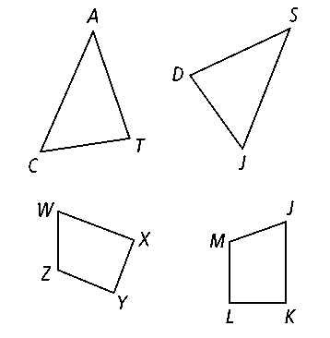**Δ*CAT*** ≅ **Δ*JSD.* List each of the following.**

**22.** three pairs of congruent sides

**23.** three pairs of congruent angles