Name

Class

Date

Parallel Lines and Triangles

**Find *m***∠**1.**

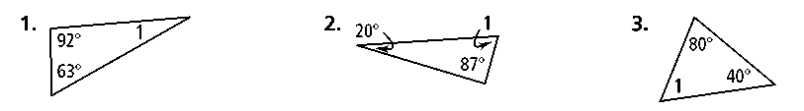**1. 2. 3.**

**Find the value of each variable.**

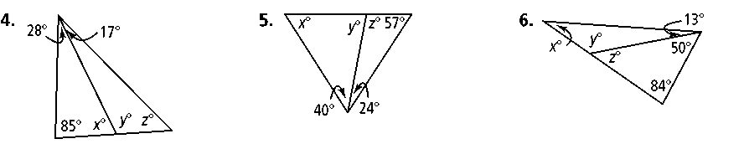**4. 5. 6.**

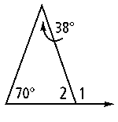

**7.** Use the diagram at the right to answer the questions.

**a.** Which angle is an exterior angle?

**b.** What are its remote interior angles?

**c.** Find *m*∠1 and *m*∠2.

**Find the value of the variables and the measures of the angles.**

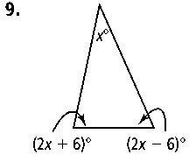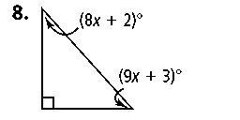**8. 9.**

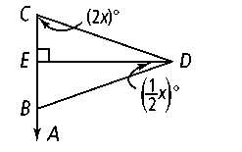**10.** In the figure at the right, .. ⊥ and ** bisects ∠*CDB.* Find *m*∠*DBA.*

**11.** The ratio of the angle measures of the acute angles in a right triangle is 2 : 3. Find the measures of the acute angles.

**12.** A ramp built for wheelchairs is shown below.

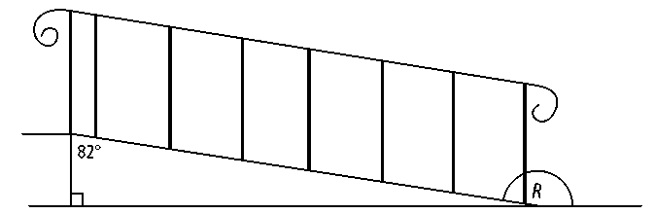

**a.** Find the measures of the remote interior angles for *∠R.*

**b.** Find *m∠R.*

**Find each missing angle measure.**

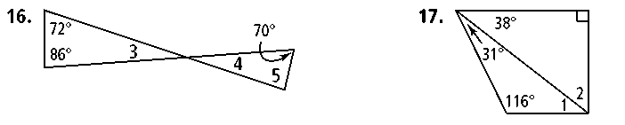 **13. 14.**

**15. Reasoning** Two angles of a triangle measure 53 and 39. What is the measure of the largest exterior angle of the triangle? Explain.