Name

Class

Date

4.11 Medians and Altitudes

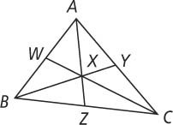

**In** Δ***ABC, X* is the centroid.**

**1.** If *CW* = 15, find *CX* and *XW.*

**2.** If *BX* = 8, find *BY* and *XY.*

**3.** If *XZ* = 3, find *AX* and *AZ.*

**Is a *median,* an *altitude,* or *neither?* Explain.**

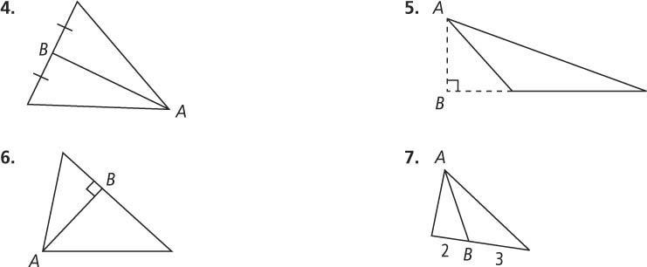**4. 5.**

**6. 7.**

**Coordinate Geometry Find the orthocenter of** Δ***ABC.***

**8.** *A*(2, 0), *B*(2, 4), *C*(6, 0) **9.** *A*(1, 1), *B*(3, 4), *C*(6, 1)

**10.** Name the centroid. **11.** Name the orthocenter.

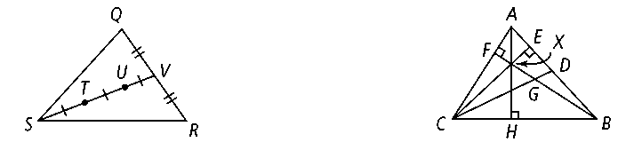

**In Exercises 12–16, name each segment.**

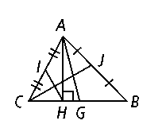

**12.** a median in Δ*ABC*

**13.** an altitude for Δ*ABC*

**14.** a median in Δ*AHC*

**15.** an altitude for Δ*AHB*

**16.** an altitude for Δ*AHG*

**17*.*** *A*(0, 0), *B*(0, −2), *C*(−3, 0). Find the orthocenter of Δ*ABC.*

**18.** In which kind of triangle is the centroid at the same point as the orthocenter?

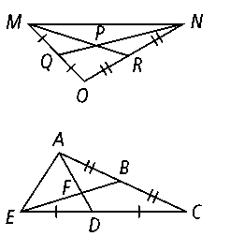

**19*.*** *P* is the centroid of Δ*MNO. MP* = 14*x* + 8*y.* Write expressions to represent *PR* and *MR.*

**20*.*** *F* is the centroid of Δ*ACE. AD* = 15*x*2 + 3*y.* Write expressions to represent *AF* and *FD.*