Name
Class
Date

4.10 Bisectors in Triangles
Coordinate Geometry Find the circumcenter of each triangle.

1. 2. 3.
Coordinate Geometry Find the circumcenter of ABC.
4. A(1, 3) 5. A(2, −3) 6. A(−5, −2) 7. A(5, 6)
B(4, 3) B(−4, −3) B(1, −2) B(0, 6)
C(4, 2) C(−4, −7) C(1, 6) C(0, −3)
Name the point of concurrency of the angle bisectors.
8. 9. 10.

11. 12. 13.

Find the value of x.
14. 15. 16.

17. 18. 19.

20. Where should the farmer place the hay bale so that it is equidistant from the three gates?
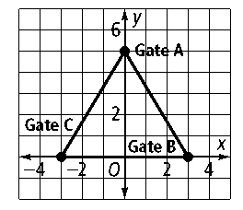

21. Where should the fire station be placed so that it is equidistant from the grocery store, the hospital, and the police station?
