Name

Class

Date

3.4 Parallel and Perpendicular Lines

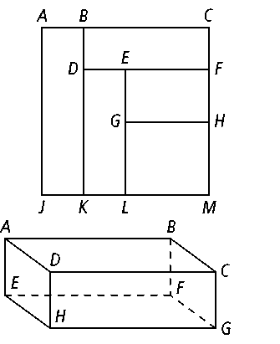**1.** Suppose you are laying tiles. You place several different rectangles together to form a larger rectangle.

**a. **is parallel to*,* is parallel to *.* What is the relationship between ****and*?* Explain.

**b.** is parallel to *.* is perpendicular to *.* What is the relationship between and *?*

**2. Error Analysis** A student says that according to Theorem 3-8,  and ** must be parallel because they are both perpendicular to **. Explain the student’s error.

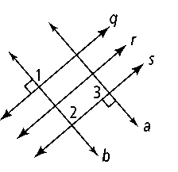

**3. Developing Proof** Copy and complete this paragraph proof.

**Given:** *q* ║ *r, r* ║ *s, b* ⊥ *q,* and *a* ⊥ *s*

**Prove:** *a* ║ *b*

**Proof:** Because it is given that *q* ║ *r* and *r* ║ *s,* then *q* ║ *s*

by the . This means that ∠1 ≅ ∠

because they are . Because *b* ⊥ *q, m*∠1 = 90. So, *m*∠2 =______. This means *s* ⊥ *b,* by definition of perpendicular lines. It is given that *a* ⊥ *s,* so *a* ║ *b* by Theorem ______.

**4. Open-Ended** Draw a diagram that meets the criteria listed below. Then describe how all the lines are related to each other.

**a.** *q* ║ *r* **b.** *r* ⊥ *s*

**c.** *t* ║ *q* **d.** *u* ⊥ *t*

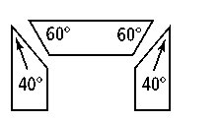

**5.** A puppeteer cuts the pieces shown at the right to frame the stage of a puppet theater. Will the sides of the pieces on the left and right be parallel?

**In Exercises 6 and 7, *a, b, c,* and *d* are distinct lines in the same plane. For each combination of relationships, tell how *a* and *c* relate. Justify your answer.**

**6.** *a* ⊥ *b; b* ⊥ *c* **7.** *a* ⊥ *b; b* ║ *c*

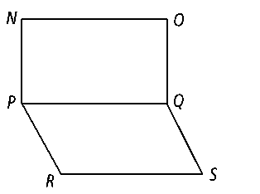

**8.** Write a two column proof.

**Given:** 

∠*PQS* and ∠*QSR* are supplementary.

**Prove:** 

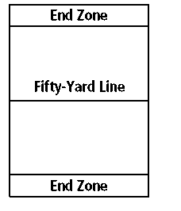

**9.** The recreation department is setting up the football field. They check to make sure that the 50-yd line and the end zone lines are perpendicular to the right sideline. Does this mean both sidelines are parallel? Explain.

**10. Draw a Diagram** Apple Road is perpendicular to Blueberry Lane. Blueberry Lane is parallel to Cornflower Drive. Cornflower Drive is perpendicular to Daffodil Lane. Daffodil Lane is parallel to Evergreen Drive. Draw a diagram to explain how each street is related to every other street. What can you conclude about Apple Road and Evergreen Drive? Explain.

**The following statements describe a set of railroad tracks. Based only on the statement, make a conclusion about the rails or the railroad ties. Explain.**

**12.** The railroad ties are each perpendicular to one rail.

**13.** The rails are parallel. One railroad tie is perpendicular to one rail.