Name
Class
Date

Proving Lines Parallel

Which lines or segments are parallel? Justify your answer.

1. 2. 3.

4. 5. 6.

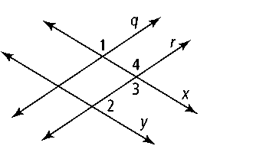
7. Developing Proof Complete the flow proof below.
Given: ∠1 and ∠2 are supplementary; x ║ y
Prove: q ║ r

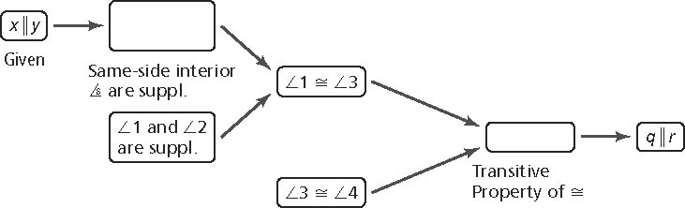

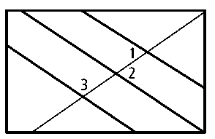
8. The art club is designing a new flag for the marching band. In the diagram, m∠1 = 45, m∠2 = 45, and
m∠3 = 145. Does the flag contain three parallel lines? Explain.

Algebra Determine the value of x for which r ║ s. Then find the measure of each labeled angle.

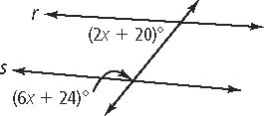
9. 10. 11.

12. 13. 14.

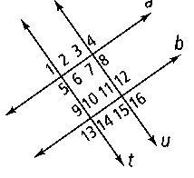
Developing Proof Use the given information to determine which lines, if any, are parallel. Justify each conclusion with a theorem or postulate.
15. ∠11 is supplementary to ∠10. 16. ∠6 ≅ ∠9
17. ∠13 is supplementary to ∠14. 18. ∠13 ≅ ∠15
19. ∠12 is supplementary to ∠3. 20. ∠2 ≅ ∠13

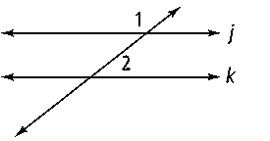
Algebra Determine the value of x for which j ║ k. Then find m∠1 and m∠2.
21. m∠1 = 7x + 14, m∠2 = 2x + 4
22. m∠1 = 4x − 5, m∠2 = x + 20

