Name
Class
Date

3.2 Properties of Parallel Lines

Identify all the numbered angles that are congruent to the given angle. Justify your answers.
1. 2.

3. 4.

Find m∠1 and m∠2. Justify each answer.
5. 6.

7. 8.

Algebra Find the value of x and y. Then find the measure of each labeled angle.
9. 10.

11. 12.

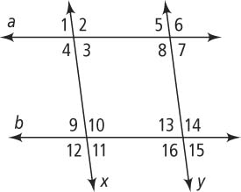
13. Write a two-column proof.
Given: a ║ b, x ║ y
Statements
Reasons
Prove: ∠4 is supplementary to ∠15.

14. Error Analysis Which solution for the figure at the right is incorrect? Explain.
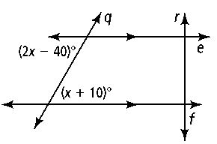
2x − 40 = x + 10 2x − 40 + (x + 10) = 180
x − 40 = 10 3x − 30 = 180
x = 50 3x = 210
x = 70
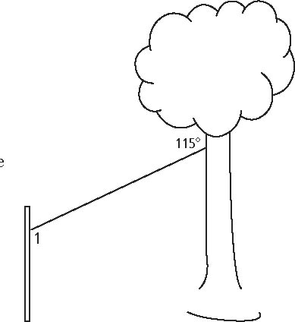
15. A zip line consists of a pulley attached to a cable that is strung at an angle between two objects. In the zip line at the right, one end of the cable is attached to a tree. The other end is attached to a post parallel to the tree. What is the measure of ∠1? What type of angle pair do ∠1 and the given angle represent?

