Name

Class

Date

3.1 Lines and Angles

**Use the diagram to name each of the following.**

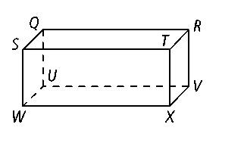

**1.** a pair of parallel planes

**2.** all lines that are parallel to 

**3.** four lines that are skew to 

**4.** all lines that are parallel to plane *QUVR*

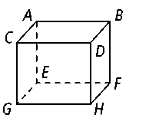

**5.** a plane parallel to plane *QUWS*

**In Exercises 6–11, describe the statement as *true* or *false.* If false, explain.**

**6.** and are skew lines. **7.** plane *DBF* ║plane *ABD*

**8.** ║ **9.** ║ 

**10.** plane *EFH* ║ plane *ABD* **11.** and are skew lines.

**12.** You are driving over a bridge that runs east to west. Below the bridge, a highway runs north to south. Are the bridge and the highway *parallel, skew,* or *neither?* Explain.

**14.** Your friend says that the sides of a ladder and the rungs of a ladder are skew. Is this true? Explain.

**15.** If two planes are parallel, must all lines within those planes be parallel? Explain.

**16. Draw a Diagram** Line *e* intersects trapezoid *ABCD.* Sketch a diagram that meets the following conditions.

**a. **and  are parallel.

**b.** ∠1 and ∠6 are alternate exterior angles.

**c.** ∠2 and ∠3 are same-side interior angles.

**d.** ∠4 and ∠5 are each supplementary to ∠3.

**Identify all pairs of each type of angle in the diagram below right.**

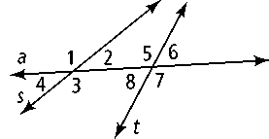

**17.** corresponding angles

**18.** same-side interior angles

**19.** alternate interior angles

**20.** alternate exterior angles

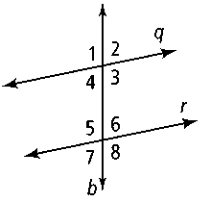

**Decide whether the angles are *alternate interior angles, same-side interior angles, corresponding angles,* or *alternate exterior angles.***

**21.** ∠2 and ∠7 **22.** ∠5 and ∠4

**23.** ∠8 and ∠3 **24.** ∠6 and ∠4

**25.** ∠1 and ∠5

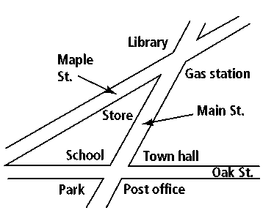

**26.** The map at the right shows the intersection of Maple Street and Oak Street by Main Street. Name the angle pairs represented by the locations listed below.

**a.** town hall and gas station

**b.** school and library

**c.** library and post office

**d.** school and gas station